Non-Parametric Tests Tutorial
Your Name
2024-11-11

Introduction
This tutorial demonstrates how to perform non-parametric tests in R using examples from the provided PDF. We will cover the following tests:
- One-sample Wilcoxon test
- Two-sample Wilcoxon test (Mann-Whitney test)

Example 1: Manufacturer’s Claim on Cola Caffeine Content
A manufacturer claims that the average caffeine content in a bottle of their cola is 0.64. The caffeine content of 16 randomly selected bottles is given as follows:
x <- c(0.60, 0.65, 0.73, 0.58, 0.71, 0.69, 0.63, 0.54, 0.70, 0.68, 0.74, 0.77, 0.73, 0.73, 0.74, 0.76)

Checking Normality
We first check the normality of the data using a histogram, Q-Q plot, and the Shapiro-Wilk test:
hist(x, main="Histogram of Caffeine Content", xlab="Caffeine Content")
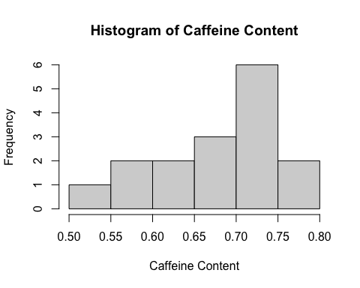
qqnorm(x)
qqline(x)
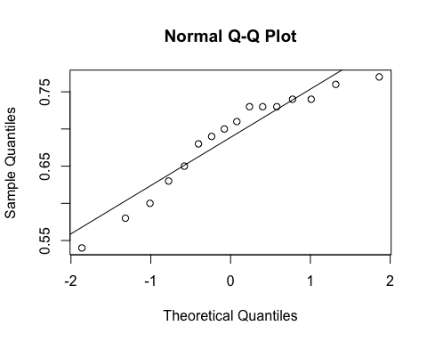
shapiro.test(x)
##
## Shapiro-Wilk normality test
##
## data: x
## W = 0.91036, p-value = 0.1179

Parametric Test: One-Sample t-test
We perform a one-sample t-test to check if the mean caffeine content is 0.64:
t.test(x, mu=0.64)
##
## One Sample t-test
##
## data: x
## t = 2.7203, df = 15, p-value = 0.0158
## alternative hypothesis: true mean is not equal to 0.64
## 95 percent confidence interval:
## 0.6500114 0.7224886
## sample estimates:
## mean of x
## 0.68625

Non-Parametric Test: Wilcoxon Signed Rank Test
Since the data may not be normally distributed, we use the Wilcoxon signed rank test as a non-parametric alternative:
wilcox.test(x, mu=0.64)
## Warning in wilcox.test.default(x, mu = 0.64): cannot compute exact p-value with
## ties
##
## Wilcoxon signed rank test with continuity correction
##
## data: x
## V = 111, p-value = 0.02771
## alternative hypothesis: true location is not equal to 0.64

Example 2: Ages of Women Having Their First Babies
A random sample of ages of women admitted to a hospital to have their first babies is given. We want to test if the median age is less than or equal to 21:
ages <- c(19, 24, 23, 20, 21, 19, 25, 18, 26, 29, 30, 28, 24, 17)
wilcox.test(ages, mu=21, alternative="less")
## Warning in wilcox.test.default(ages, mu = 21, alternative = "less"): cannot
## compute exact p-value with ties
## Warning in wilcox.test.default(ages, mu = 21, alternative = "less"): cannot
## compute exact p-value with zeroes
##
## Wilcoxon signed rank test with continuity correction
##
## data: ages
## V = 69.5, p-value = 0.957
## alternative hypothesis: true location is less than 21
Does this seem right? Make sure you have the correct alternative hypothesis for the test. Investigate the options for this test relating to the exact compuation of the p-value and the continutiy correction.

Example 3: Effect of Display on Sales
A supermarket wants to test the effect of a display on selling a certain item. The sales data with and without the display are given as follows:
without_display <- c(72, 90, 84, 65, 83, 70, 75, 65, 55, 62, 63, 71, 80, 91)
with_display <- c(80, 70, 95, 108, 100, 72, 85, 75, 75, 69, 101)
wilcox.test(without_display, with_display, alternative="greater")
## Warning in wilcox.test.default(without_display, with_display, alternative =
## "greater"): cannot compute exact p-value with ties
##
## Wilcoxon rank sum test with continuity correction
##
## data: without_display and with_display
## W = 41.5, p-value = 0.9758
## alternative hypothesis: true location shift is greater than 0
This template provides a comprehensive guide to performing non-parametric tests in R. You can expand on this by adding more explanations, interpretations of the results, and additional examples as needed. Happy analyzing! 📊
Source: Conversation with Copilot, 11/11/2024 (1) 7MA505_Tutorial_Nonparametric.pdf

